PET SHOP

an owl – sova

a spider – pauk

a fish – riba

a parrot – papiga

a turtle – kornjača

a snake – zmija

a dog – pas

a cat – mačka

a monkey – majmun

a fox – lisica

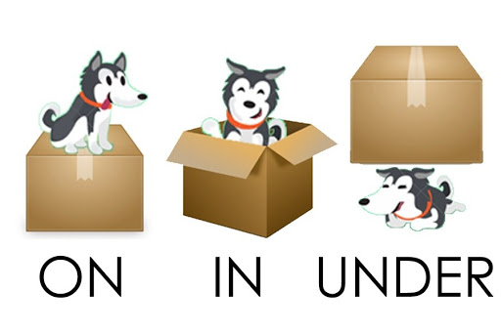

The dog is on the box. - Pas je na kutiji.

The dog is in the box. - Pas je u kutiji.

The dog is under the box. - Pas je ispod kutije.

